Strategic Planning and Data Exploration in Logistics
Week 1 Task – Data Analytics Internship
Submitted By: Vineet Singh
Program: Bachelor of Computer Applications (BCA)
Role: Data Analytics Intern

1. Background Research
Logistics is an important part of the supply chain because it helps move products from suppliers and warehouses to customers on time. A logistics company has to manage a lot of information, such as orders, delivery locations, transportation costs, delivery time, vehicle usage, and customer demand. Looking at this data can help the company find delivery delays, control transportation costs, use resources better, and improve customer satisfaction.
For this project, I have considered a logistics company that is facing problems such as delayed deliveries, inefficient routes, and increasing operational costs. The company wants to use data analysis to understand its delivery performance and make better decisions. Historical logistics data can be analyzed using Python to find useful patterns, calculate important KPIs, and understand where improvements are needed in the delivery process.
To understand the problem, publicly available logistics and supply chain datasets can be used. Such datasets may contain information like order date, delivery date, shipment distance, delivery status, transportation cost, product category, quantity, location, and delivery time. By studying these variables, it becomes possible to find out which factors may be related to delivery delays and higher costs.
Different data science techniques can be used to analyze this type of problem. Exploratory Data Analysis (EDA) can help understand the data and find patterns, while regression can be used to study factors that affect delivery time or cost. Clustering can help group similar locations or deliveries, and optimization can be useful for improving routes and resource allocation. The main goal of this project is to use the available data to find useful insights that can help the logistics company improve its delivery performance and make better decisions.

2. Project Definition
2.1 Logistics Scenario
The project focuses on the delivery operations of a logistics company that delivers products from warehouses to customers in different locations. The company handles many orders every day, so managing delivery time, routes, vehicles, and transportation costs is important.
The company may face problems such as late deliveries, higher transportation costs, and inefficient use of vehicles. These problems can affect customer satisfaction and increase the overall cost of the business.
In this project, historical logistics data will be analyzed using Python. The data can include information such as order date, delivery date, distance, delivery status, transportation cost, location, quantity, and delivery time. By studying this information, useful patterns can be found and areas for improvement can be identified.
The main purpose of the project is to understand delivery performance using data and provide practical suggestions that can help improve logistics operations.
2.2 Problem Statement
The main problem in this project is to understand why some deliveries are delayed and why transportation costs may be higher for certain shipments or routes.
Without proper analysis, it can be difficult for a logistics company to identify which routes have more delays, which locations have delivery problems, and which factors affect delivery time and cost.
In this project, the logistics data will be analyzed to find these patterns. Important KPIs will also be calculated to measure delivery performance. Data science techniques will then be used to understand the data and provide useful suggestions for improving delivery performance, reducing unnecessary costs, and using available resources more effectively.

3. Project Objectives
1. To understand the overall delivery performance of the logistics company.
2. To identify the main reasons for delivery delays and higher transportation costs.
3. To calculate important KPIs such as delivery time, delivery delay rate, and transportation cost.
4. To use Python and data analysis techniques to find useful patterns in the logistics data.
5. To provide practical suggestions that can help improve delivery performance and resource utilization.

4. Key Performance Indicators (KPIs)
To measure the performance of the logistics operations, the following KPIs will be used. These KPIs will help in understanding delivery performance, delays, and transportation costs.
4.1 On-Time Delivery Rate
This KPI shows the percentage of orders that are delivered on or before the expected delivery date. A higher on-time delivery rate indicates better delivery performance.
4.2 Average Delivery Time
This KPI measures the average time taken to deliver an order from the time it is placed or dispatched until it reaches the customer. It can help identify delays in the delivery process.
4.3 Delivery Delay Rate
This KPI shows the percentage of deliveries that were completed after the expected delivery date. A high delay rate may indicate problems with routes, transportation, or operational planning.
4.4 Transportation Cost per Delivery
This KPI measures the average transportation cost for each delivery. It can help the company compare delivery costs and identify areas where transportation expenses can be reduced.
4.5 Order Fulfillment Rate
This KPI shows the percentage of customer orders that are successfully completed. A higher fulfillment rate indicates that the company is able to handle customer orders effectively.

5. Literature and Data Research
For this project, publicly available logistics and supply chain data can be used to understand delivery performance and transportation operations. Public datasets are useful because they provide real-world examples of orders, deliveries, shipment details, costs, and other logistics-related information.
One possible source is Kaggle, where different logistics and supply chain datasets are available for learning and analysis. These datasets can contain information such as order details, shipping mode, delivery status, product information, location, sales, and transportation-related data.
The selected dataset will be examined before starting the analysis to understand its columns, data types, missing values, and overall structure. The data will then be cleaned and prepared using Python libraries such as Pandas and NumPy. After cleaning, the dataset can be explored using charts and statistical methods to identify important patterns.
Publicly available resources and existing research will also be used to understand common logistics problems such as delivery delays, route efficiency, inventory management, and transportation costs. This background research will help in selecting suitable KPIs and data science techniques for the project.

6. Data Science Methodologies
6.1 Exploratory Data Analysis (EDA)
EDA will be used to understand the logistics dataset before applying any advanced technique. It will help identify patterns, unusual values, missing data, and relationships between different variables. Charts and summary statistics will be used to understand delivery time, costs, delays, and other important factors.
6.2 Regression Analysis
Regression can be used to understand which factors may affect delivery time or transportation cost. For example, shipment distance, quantity, or other available variables can be compared with delivery time to understand their relationship.
6.3 Clustering
Clustering can be used to group similar deliveries or locations based on factors such as delivery time, distance, cost, or order quantity. These groups may help the company understand which areas or types of deliveries have similar operational requirements.
6.4 Optimization
Optimization techniques can be used to find better ways of using available logistics resources. For example, route and resource information can be analyzed to reduce unnecessary travel distance and transportation costs while maintaining good delivery performance.

7. Strategic Roadmap
7.1 Data Collection
Collect a suitable public logistics dataset and understand the available variables such as orders, delivery dates, distance, cost, location, and delivery status.
7.2 Data Cleaning
Check the dataset for missing values, duplicate records, incorrect data types, and unusual values. Clean the data before starting the analysis.
7.3 Exploratory Data Analysis
Use Python, Pandas, and visualization libraries to study the data. Analyze delivery times, costs, delays, locations, and other important variables.
7.4 KPI Analysis
Calculate the selected KPIs such as on-time delivery rate, average delivery time, delivery delay rate, transportation cost per delivery, and order fulfillment rate.
7.5 Predictive and Advanced Analysis
Apply suitable techniques such as regression and clustering to understand important patterns and relationships in the data. Optimization can also be considered for route and resource planning.
7.6 Insights and Recommendations
Summarize the main findings and provide practical recommendations that can help improve delivery performance, reduce costs, and use resources more effectively.

8. Python Code Illustration
Python will be used for data cleaning, exploration, visualization, and analysis. The following code snippets show some of the basic steps that can be used in the proposed logistics analysis.
8.1 Importing Libraries
import pandas as pd
import numpy as np
import matplotlib.pyplot as plt

# Load the logistics dataset
df = pd.read_csv("../03_Data/Delivery_Logistics.csv")

# Display the first five rows
print(df.head())

# Check the structure of the dataset
print(df.info())

# Check the size of the dataset
print("Dataset Shape:", df.shape)
8.2 Checking Missing Values
# Check missing values in each column
print(df.isnull().sum())

# Check duplicate records
print("Duplicate Records:", df.duplicated().sum())
8.3 Basic Data Analysis
# Get basic statistics
print(df.describe())
# Calculate average delivery time
average_delivery_time = df["delivery_time_hours"].mean()
print("Average Delivery Time:", round(average_delivery_time, 2), "hours")

# Calculate average transportation cost
average_delivery_cost = df["delivery_cost"].mean()
print("Average Transportation Cost per Delivery:",
round(average_delivery_cost, 2))
8.4 Data Cleaning for Time Columns
# Convert delivery time from timestamp format to hours
df["delivery_time_hours"] = pd.to_datetime(
df["delivery_time_hours"]
).
dt.nanosecond
# Convert expected delivery time to hours
df["expected_time_hours"] = pd.to_datetime(
df["expected_time_hours"]
).
dt.nanosecond
# Display the converted values
print(df[["delivery_time_hours", "expected_time_hours"]].head())

8.5 KPI Analysis
# Calculate On-Time Delivery Rate
on_time_rate = (df["delayed"] == "no").mean() * 100
print("On-Time Delivery Rate:", round(on_time_rate, 2), "%")

# Calculate Delivery Delay Rate
delay_rate = (df["delayed"] == "yes").mean() * 100
print("Delivery Delay Rate:", round(delay_rate, 2), "%")

# Calculate Order Fulfillment Rate
fulfillment_rate = (df["delivery_status"] == "delivered").mean() * 100
print("Order Fulfillment Rate:", round(fulfillment_rate, 2), "%")

# Calculate Average Delivery Cost
average_cost = df["delivery_cost"].mean()
print("Average Transportation Cost:", round(average_cost, 2))

9. Analysis Findings and Expected Outcomes
9.1 Actual Findings
The Python analysis of the logistics dataset provided useful insights into delivery performance and operational patterns. The dataset contains 25,000 delivery records and 15 columns. There were no missing values or duplicate records in the dataset after the initial data check.
The analysis showed an On-Time Delivery Rate of 73.32% and a Delivery Delay Rate of 26.68%. The average delivery time was 6.25 hours, while the average expected delivery time was 13.11 hours. The average transportation cost per delivery was approximately 864.94.
Weather conditions showed a noticeable difference in delivery delays. The highest delay rate was observed during stormy weather at 41.45%, followed by rainy weather at 37.35% and foggy weather at 30.32%. Delay rates were comparatively lower during clear, hot, and cold weather conditions.
Delivery mode analysis also showed differences in delay rates. The delay rate was highest for express deliveries at 73.78%, followed by same-day deliveries at 32.54%. The delay rate for two-day deliveries was very low at 0.43%.
Figure 1: Delivery Status Distribution
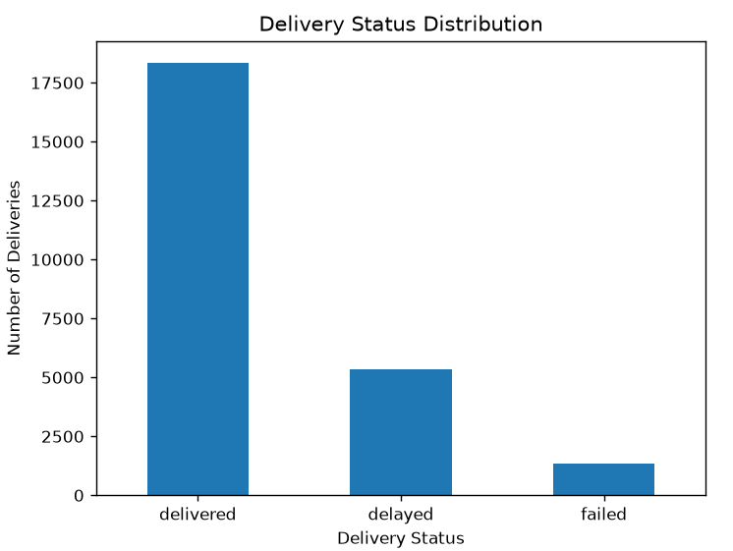
Figure 2: Delivery Delay Rate by Weather Condition
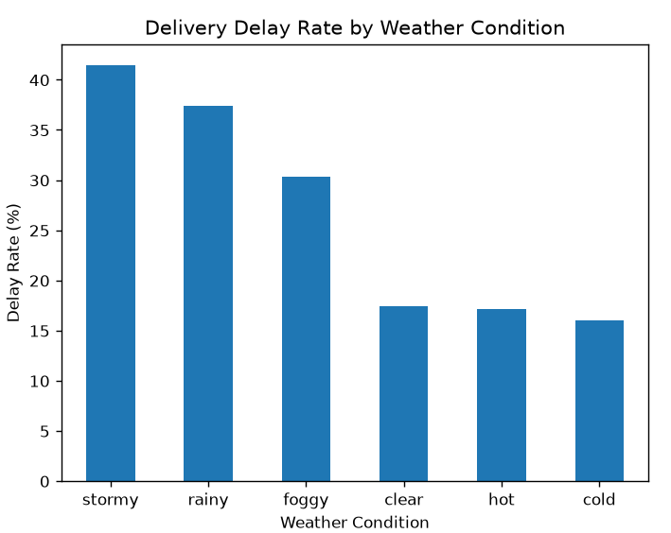

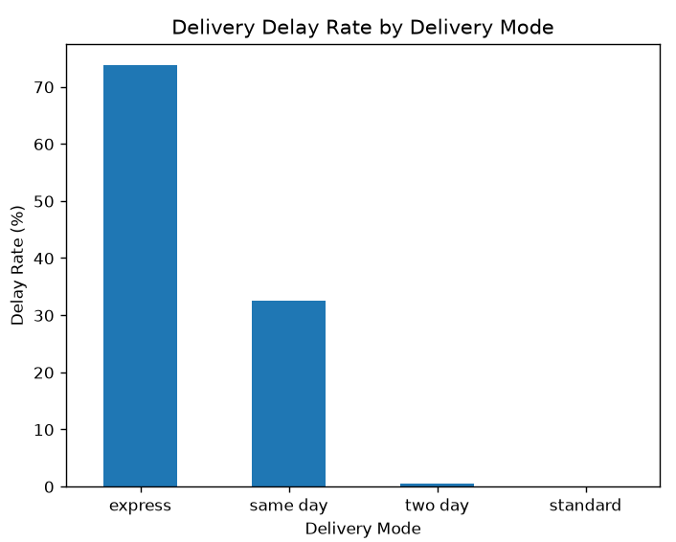
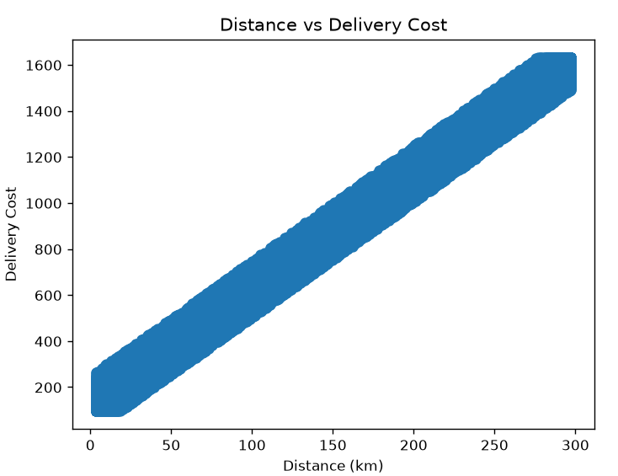
Figure 4: Distance vs Delivery Cost

9.2 Key Insights
The analysis indicates that delivery performance can be affected by different operational conditions. Weather conditions showed a clear difference in delay rates, with stormy and rainy conditions having higher delay rates. This suggests that weather conditions should be considered while planning deliveries.
The analysis also showed differences between delivery modes. Express and same-day deliveries had higher delay rates compared with two-day and standard deliveries. This indicates that delivery time commitments may need to be considered carefully while planning resources.
Overall, the findings can help the logistics company identify areas where delivery performance can be improved. The results can also support better planning of routes, delivery resources, and transportation operations.

9.3 Recommendations
Based on the analysis, the logistics company can take several steps to improve delivery performance. Deliveries during stormy and rainy weather should be planned more carefully, as these conditions showed higher delay rates. Additional time or alternative planning can be considered for deliveries during difficult weather conditions.
Express and same-day deliveries should also receive proper resource planning because they showed higher delay rates in the analysis. The company can monitor these delivery modes more closely and allocate suitable vehicles and delivery resources according to demand.
The company can also regularly monitor KPIs such as on-time delivery rate, delay rate, average delivery time, and transportation cost. Continuous monitoring of these KPIs can help identify performance problems early and support better operational decisions.

10. Conclusion
This project demonstrates how data analysis can be used to understand and improve logistics operations. The analysis focused on delivery performance, delays, transportation costs, and operational conditions.
The Python analysis showed an On-Time Delivery Rate of 73.32% and a Delivery Delay Rate of 26.68%. The analysis also identified higher delay rates during stormy and rainy weather and in express and same-day delivery modes. These findings can help the company focus on areas that may require better planning and resource allocation.
Overall, the use of Python, KPI analysis, data exploration, and visualization provides a useful data-driven approach for logistics planning. Regular analysis of delivery performance can help the company make better operational decisions, improve delivery efficiency, and control unnecessary transportation costs.

11. References and Data Source
Dataset Source: Kaggle – Delivery Logistics Performance & Operations Dataset
Dataset File: Delivery_Logistics.csv
Source: Kaggle
Dataset Link: https://www.kaggle.com/datasets/ayeshaseherr/delivery-logistics-dataset
Tools Used:
- Python
- Pandas
- NumPy
- Matplotlib
- Visual Studio Code
The dataset was used for learning and analysis purposes in this Week 1 Data Analytics Internship task.

